Method Resolution Order :
Method Resolution Order(MRO) it denotes the way a programming language resolves a method or attribute. Python supports classes inheriting from other classes. The class being inherited is called the Parent or Superclass, while the class that inherits is called the Child or Subclass. In python, method resolution order defines the order in which the base classes are searched when executing a method. First, the method or attribute is searched within a class and then it follows the order we specified while inheriting. This order is also called Linearization of a class and set of rules are called MRO(Method Resolution Order). While inheriting from another class, the interpreter needs a way to resolve the methods that are being called via an instance. Thus we need the method resolution order.
DLR Algorithm
During implementing multiple inheritances, Python builds a list of classes to search as it needs to resolve which method has to be called when one is invoked by an instance. As the name suggests, the method resolution order will search the DEPTH-FIRST, then go LEFT to RIGHT.

C3 Linearization Algorithm :
C3 Linearization algorithm is an algorithm that uses new-style classes. It is used to remove an inconsistency created by DLR Algorithm. It has certain limitation they are:
- Children precede their parents
- If a class inherits from multiple classes, they are kept in the order specified in the tuple of the base class.
C3 Linearization Algorithm works on three rules:
- Inheritance graph determines the structure of method resolution order.
- User have to visit the super class only after the method of the local classes are visited.
- Monotonicity

Case 1
This is a simple case where we have class C derived from both A and B. When method process() is called with object of class C then process() method in class A is called.
Python constructs the order in which it will look for a method in the hierarchy of classes. It uses this order, known as MRO, to determine which method it actually calls.
It is possible to see MRO of a class using mro() method of the class.
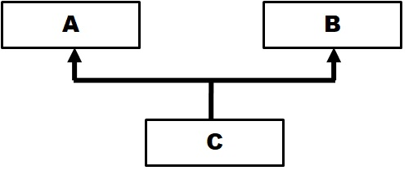
class A:
def process(self):
print('A process()')

class B:
pass

class C(A, B):
pass

obj = C()
obj.process()
print(C.mro()) # print MRO for class C

The above diagram illustrates hierarchy of classes.
When run, the above program displays the following output:
A process()
[<class '__main__.C'>, <class '__main__.A'>, <class '__main__.B'>, <class 'object'>]
From MRO of class C, we get to know that Python looks for a method first in class C. Then it goes to A and then to B. So, first it goes to super class given first in the list then second super class, from left to right order. Then finally Object class, which is a super class for all classes.

Case 2
Now, let’s make it a little more complicated by adding process() method to class B also.
class A:
def process(self):
print('A process()')

class B:
def process(self):
print('B process()')

class C(A, B):
pass

obj = C()
obj.process()
When you run the above code, it prints the following:
A process()
Python calls process() method in class A. According to MRO, it searches A first and then B. So if method is found in A then it calls that method.
However, it we remove process() method from class A then process() method in class B will be called as it is the next class to be searched according to MRO.
The ambiguity that arises from multiple inheritance is handled by Python using MRO.

Case 3
In this case, we create D from C and B. Classes C and B have process() method and as expected MRO chooses method from C. Remember it goes from left to right. So it searches C first and all its super classes of C and then B and all its super classes. We can observe that in MRO of the output given below.
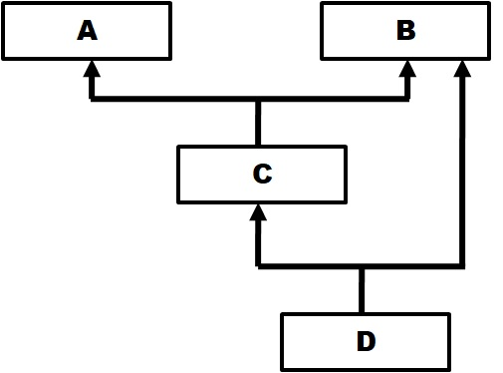
class A:
def process(self):
print('A process()')

class B:
def process(self):
print('B process()')

class C(A, B):
def process(self):
print('C process()')

class D(C,B):
pass

obj = D()
obj.process()

print(D.mro())

Running the above program will produce the following output:
C process()
[<class '__main__.D'>, <class '__main__.C'>, <class '__main__.A'>, <class '__main__.B'>, <class 'object'>]

Case 4
Now, lets change the hierarchy. We create B and C from A and then D from B and C. Method process() is present in both A and C.
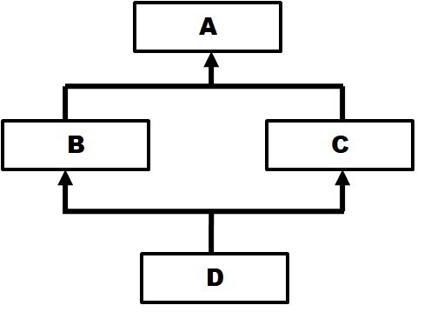
class A:
def process(self):
print('A process()')

class B(A):
pass

class C(A):
def process(self):
print('C process()')

class D(B,C):
pass

obj = D()
obj.process()
Output of the above program is:
C process()
[<class '__main__.D'>, <class '__main__.B'>, <class '__main__.C'>, <class '__main__.A'>, <class 'object'>]
When we call process() with an object of class D, it should start with first Super class – B (and its super classes) and then second super class – C (and its super classes). If that is the case then we will call process() method from class A as B doesn’t have it and A is super class for B.
However, that is contradictory to rule of inheritance, as most specific version must be taken first and then least specific (generic) version. So, calling process() from A, which is super class of C, is not correct as C is a direct super class of D. That means C is more specific than A. So method must come from C and not from A.
This is where Python applies a simple rule that says (known as good head question) when in MRO we have a super class before subclass then it must be removed from that position in MRO.
So the original MRO will be:
D -> B -> A -> C -> A
If you include object class also in MRO then it will be:
D -> B-> A -> object -> C -> A -> object
But as A is super class of C, it cannot be before C in MRO. So, Python removes A from that position, which results in new MRO as follows:
D -> B -> C -> A -> object
The output of the above program proves that.

Case 5
There are cases when Python cannot construct MRO owing to complexity of hierarchy. In such cases it will throw an error as demonstrated by the following code.
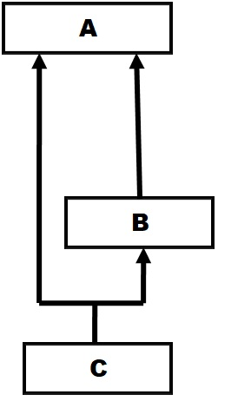
class A:
def process(self):
print('A process()')

class B(A):
def process(self):
print('B process()')

class C(A, B):
pass

obj = C()
obj.process()
When you run the above code, the following error is shown:
TypeError: Cannot create a consistent method resolution
order (MRO) for bases A, B
The problem comes from the fact that class A is a super class for both C and B. If you construct MRO then it should be like this:
C -> A -> B -> A
Then according to the rule (good head) A should NOT be ahead of B as A is super class of B. So new MRO must be like this:
C -> B -> A
But A is also direct super class of C. So, if a method is in both A and B classes then which version should class C call? According to new MRO, the version in B is called first ahead of A and that is not according to inheritance rules (specific to generic) resulting in Python to throw error.

